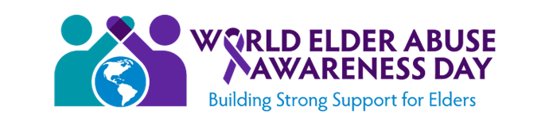

Save the Date: October 27, 2020

West Virginia Elder Abuse Awareness Day Seminar

Charleston Coliseum & Convention Center

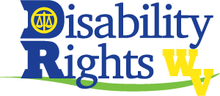
Continuing Education Pending for Social Workers, Lawyers, Law Enforcement Officers,
Nurses, Domestic Violence Advocates, and Licensed Professional Counselors

Check for Registration Updates:
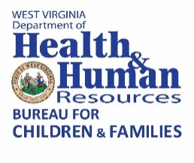
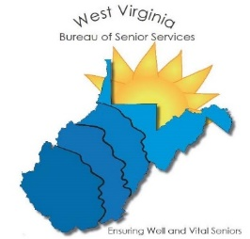
dhhr.wv.gov/bcf/Services/Pages/Elder-Abuse-Awareness-Day.aspx

